WHAT’S IN A NAME?
EXPLORING THE ORIGINS OF THE BRITISH TOY STEAM LOCOMOTIVE
By Nicholas Oddy
Pictures by the author unless otherwise credited

The world of 19th century brass locos is a confusing one. A lot of names are bandied about by collectors, Tim Armitage’s series of ‘Fragments from Forgotten Firms’ will have introduced readers to a fair number of them. However, what do these names, often finely engraved into the frames and boilers of locomotives, actually mean?

In the last five years I have become increasingly interested in what seem to be the earliest of the class of loco that would later be termed a ‘dribbler’. They have two axles, with cast bases and screwed-on outside frames and are very finely made, but very plain. They are powered by inside twin oscillating cylinders, themselves very finely cast without ribs. All share the same wheels, baseplates, boilers, cylinders, drive-gear and regulators, all have similar, rather impressive burner shielding with the heat running ‘inside’ the bottom of the boiler and up the chimney. However, there are sometimes differences in detail of safety valves, chimneys and domes. Their original finish seems always to have been bright lacquered brass. They seem to date from the 1840s and 50s. In fact, I’d go so far as to propose that these locos were those from which the UK toy and model railway industry developed. As such, they take on an important place in toy and model railway history.

Although interested in them since childhood I have only actually collected brass locos for about twenty years and, to begin with, fell into the trap of believing what is written about them. Yet, there soon seemed to be something wrong with what was generally taken for granted. Simple research on well-known makers such as Stevens’ Model Dockyard and Clyde Model Dockyard completely undermined what one would understand of their history as presented in the standard sources such as Gustav Reder’s Clockwork Steam and Electric (1969, English trns1972), Jonathan Minns’ Model Railway Locomotives (1970), and Allen Levy’s Century of Model Trains (1973). I became increasingly suspicious of the widely repeated ‘fact’, seeming to originate from Minns, that London instrument makers were manufacturing toy steam locomotives. From my own academic experience in design history, this seemed unlikely, but, without a prompt, I had no reason to test my suspicions out.

For some years, acquiring an example of one of the two-axle locos mentioned above had been high on my collecting agenda. Recently, Clem Thomas provided one. It is marked for Robert Gogerty of 72 Fleet Street Figs 1a-e. It was the prompt I required as Gogerty was a new name to me. I find that ownership spurs on the research process as it allows one to study an object at depth whenever one wants to. The loco is identical to the others I know of, except in it having a whistle and a very unusual pulley mechanism fitted to the chimney Fig 1f.

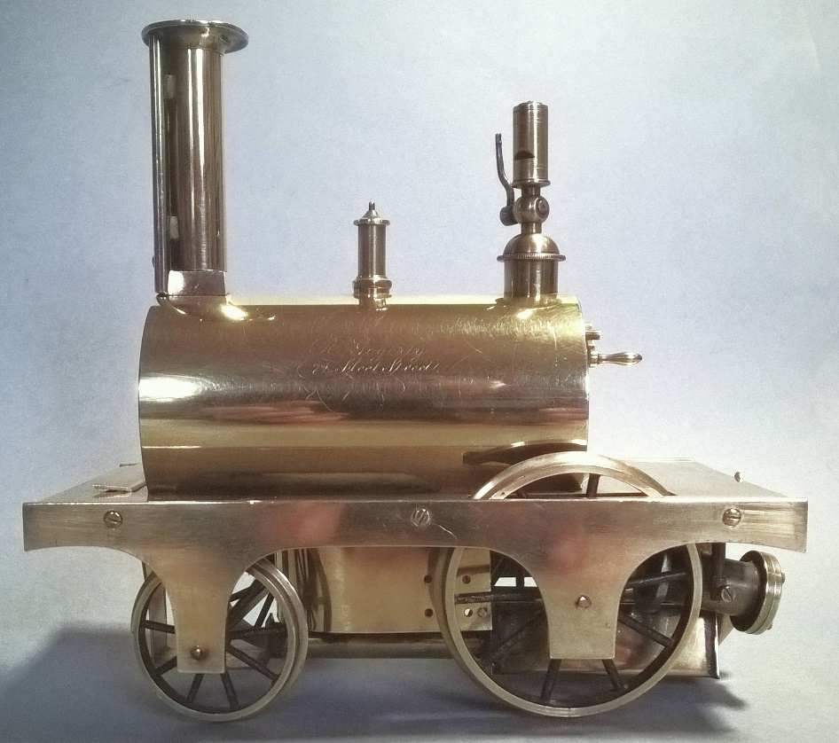
Fig 1a

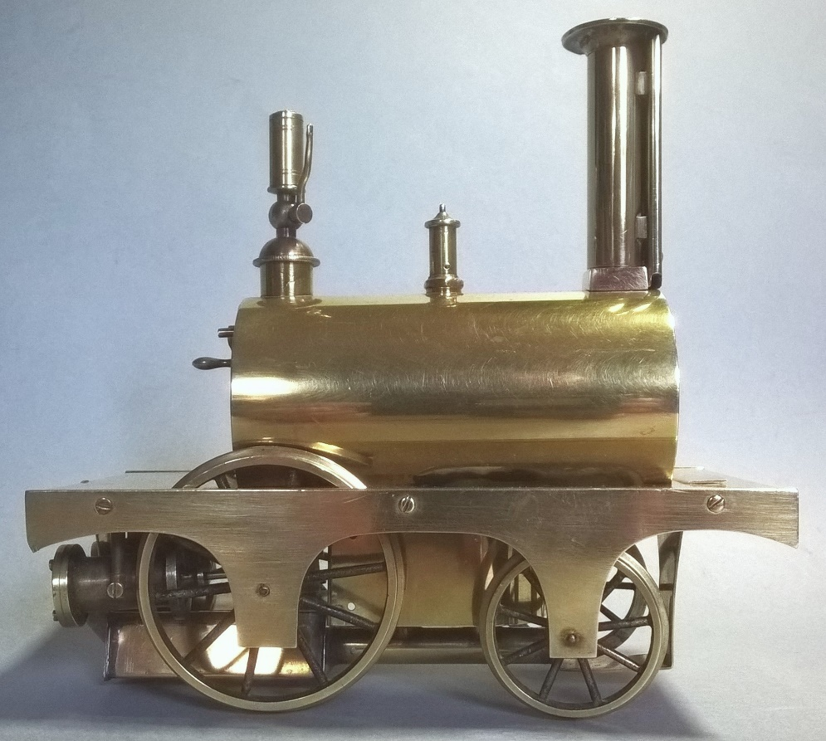
Fig 1b
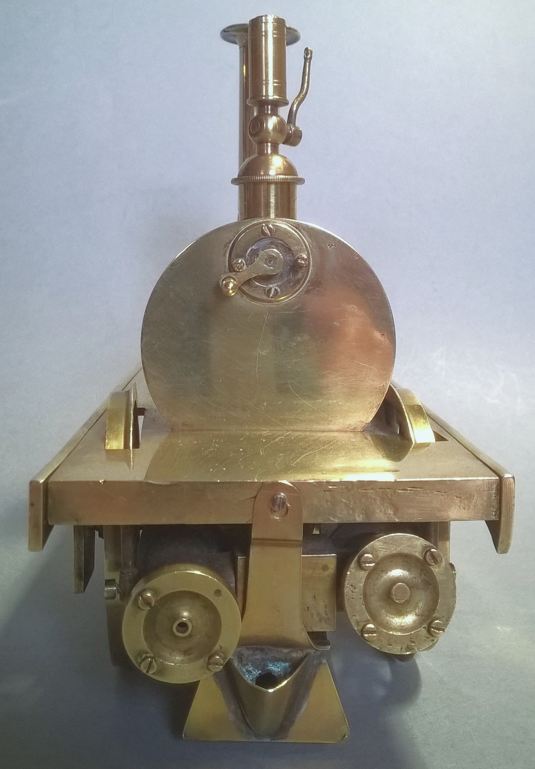
Fig 1c
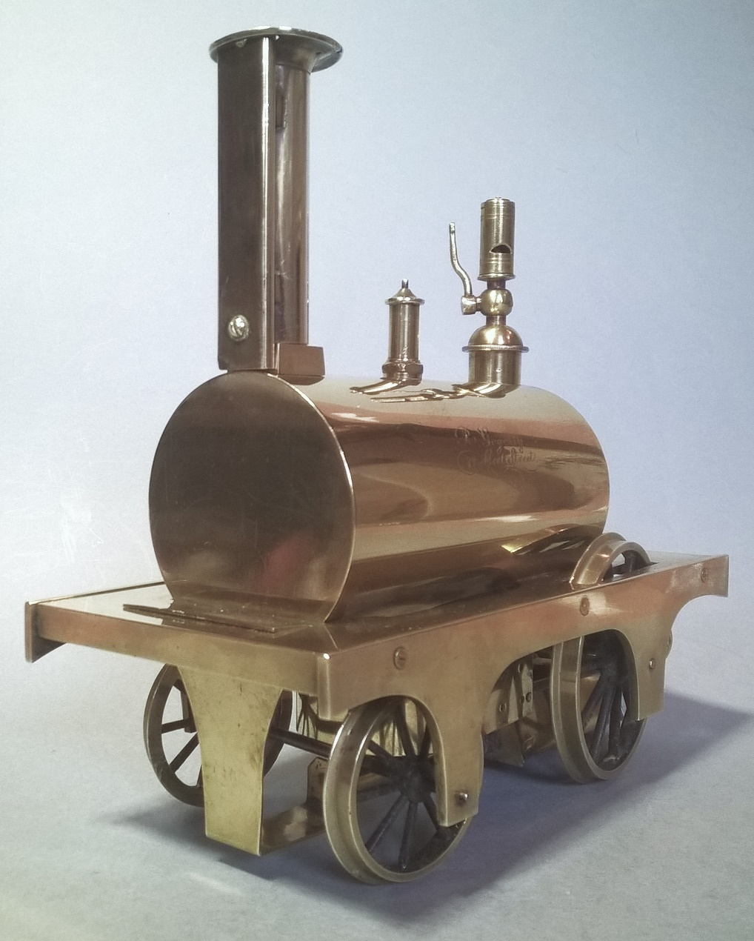
Fig 1d

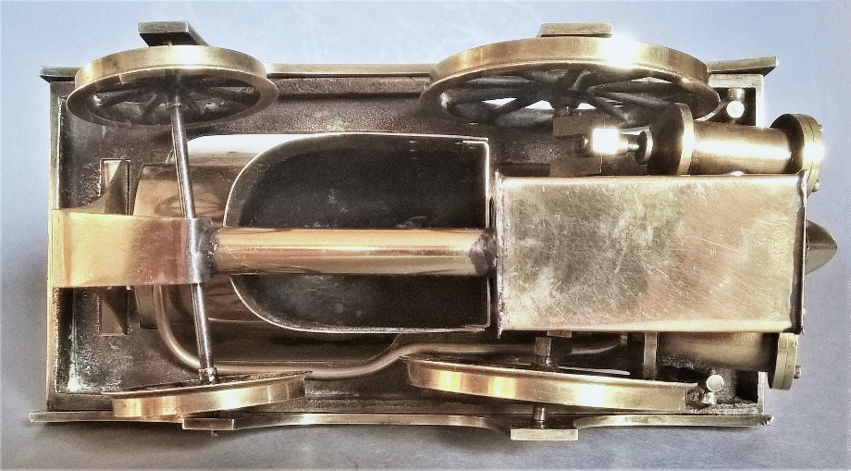
Fig 1e

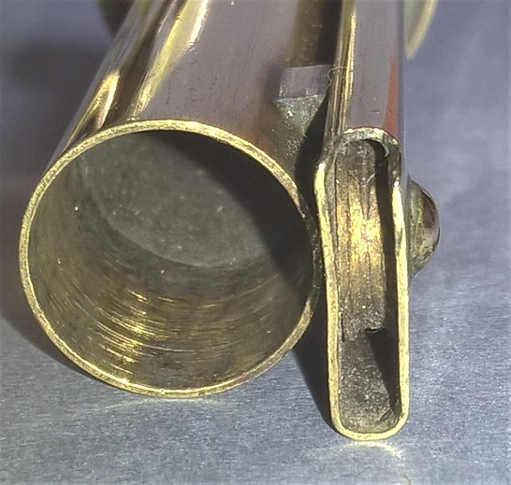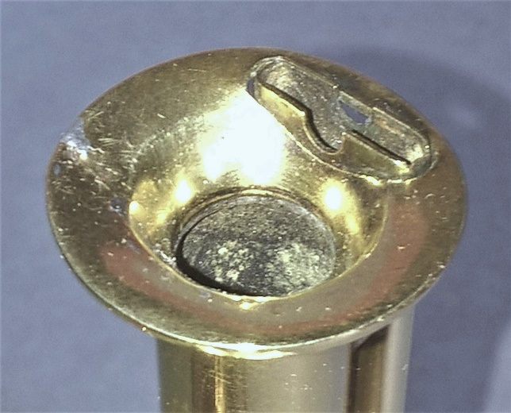
Fig 1f: The author would value any information as to what this pulley and shaft did.

A quick bit of internet research told me (not unexpectedly) that Gogerty was an ‘optician and instrument maker’ and was at this address from 1847-1856 . This dates the locomotive very nicely, but it certainly does not give any clue as to its maker. Others are marked for Watkins & Hill of Cheapside and, later, Newton & Co , also of Fleet Street. All were active in the 1850s and all were instrument makers, but surely not all of them were making the same loco? My guess was that all three were buying them in from someone else.

Let’s start with the existing approach. This has been established over many years by both collectors and dealers desirous to ascribe provenance. They have tended to work on a principle of ‘if it says it is… it is’. A name is a saleable commodity, it adds caché and is a key part of proving expertise of a connoisseurial nature when faced with anonymous but similar objects. In this model all three firms were making the locos, but copying one another, and minor differences, a whistle on one, a heating tube on another, a burner hanger on a third, are indicative of this.

While not toy trains, it is always worth looking at research on other high value products to understand the structures of ‘making’ in the 18th until the mid-19th century. I strongly recommend Helen Clifford’s Silver in London: The Parker and Wakelin Partnership (2004) for this purpose. Parker and Wakelin were one of the foremost London silversmiths of the second half of the 18th century and, because of hallmarking, almost all of what they ‘made’ is marked. There has been much published connoisseurial history that treats every item marked for Parker and Wakelin as if made by them. However, Clifford proves that there is no way the company had the capacity to make what they seem to have. Rather, they relied on anonymous outworkers in jobbing workshops to make silverware for all but their most prestigious commissions, only these latter they made themselves. The same outworkers and workshops were employed by all the other great London silversmiths of the time, often they sold identical items to a number of ‘makers’, whose marks the objects bear. Therefore, the traditional collector approach of trying to ascribe different nuances of making between a number of similar objects, but marked for different makers, is a bogus exercise. Indeed, the fact they share commonalities is an indication that they all share the same maker.

A telling paragraph on Watkins & Hill can be found at http://microscopist.net/WatkinsHill.html

Francis Watkins is particularly notable for introducing the concept of a hinged joint in the microscope limb, so that it can be inclined to a comfortable angle. His microscope designs are very distinct from those of other makers. Later microscopes from Watkins / Watkins & Hill generally followed the standard patterns of their times, and it is likely that some/all were brought in from wholesale manufacturers.

This is not uncommon in accounts of London instrument makers . That they would look outside to buy in the stuff of their own trade is telling. Why would they be making toy locomotives? Moreover, as time goes on more of these locos appear and the differences are found to be rather random. Would it not be just a lot more obvious that there was one maker who supplied instrument makers and who adjusted the product from time to time over a fairly long time-span? The problem is, of course, not putting out the theory, but proving it by establishing who the maker was.

Let us look at how the market for such items might have developed. Railways, though ‘the wonder of the age’, must surely have taken some time to be established in the public consciousness to the level of someone to think of modelling them in quantity on a commercial basis? Particularly as this was something that had no precedent. Models that can be placed earlier than the late 1840s are extremely rare and all are one-offs by individual makers, it seems mainly by amateur skilled enthusiasts rather than commercial companies. The period of rapid railway expansion was the 1840s. It is at this period the railway network as it would now be understood was really created, along with a large audience that had direct experience of railway travel and of seeing steam locomotives in action.

It is likely that it was at this time that someone saw the possibility of selling quantity made representations of locomotives as adult toys, educational curiosities that could delight a domestic audience. However, this was no epiphany by opticians and instrument makers throughout London in the way the engraved names suggest it might have been. Opticians and instrument makers had far better things to do with their time, like deal with their core business. That someone was probably more likely to be an enthusiast who saw an opportunity to make and sell locomotives as a business. London was a very likely place for such an individual to be, given the extent of real railway activity in the Metropolis and large population of potential, bourgeois customers.

I suspect both build and sales were largely speculative and ‘production led’. At this period there was little desire to have exactly the same as your neighbour; rather, those in the market tended to want something similar to their peers, but individual to the owner. It was this principle that had made Wedgwood creamware the huge success it was. A limited range of shapes was offered with well over a hundred potential borders, the customer picking both the shape and the border from pattern books, making it very unlikely that two purchasers would find themselves eating off identical crockery in each other’s houses. Therefore, it was in a maker’s interest to either offer a huge range of similar looking items but with differences between them (if large, like Wedgwood, famously the masters of retail pattern books); or to keep making minor adjustments to the things they made (if small, like a maker of toy locomotives selling speculatively to retailers). Only those firms selling remotely through pattern books (such as Wedgwood) had any need of the products or their details being exactly to any particular pattern, while a smaller concern selling ‘over the counter’ could adjust what they made at will.

The 1840s-60s trade in toy locomotives was almost certainly largely only over the counter, therefore probably fairly localised in terms of ‘reach’. So far, all these early brass locos I have recorded are marked for London retailers. How many catalogues illustrating brass locos as defined, priced products for the retail trade seem to have been produced at this period? I have yet to hear of one, further suggesting very localised production and distribution. As far as I have ascertained, the earliest ‘catalogue’ that lists and illustrates standardised brass locos is Edwin Bell’s The Model Dockyard Handy Book first published in the mid-1860s. That is well after the production of the locos discussed here and only two types of locomotive are listed. We will return to it later.

In TC 60 at pp28-33 I looked at Fire Brand, a three-axle locomotive, in great detail Figs 2a-d. But, it took Clem Thomas to point out that Fire Brand not only has the same Spartan appearance as the Gogerty loco, but also it has identical wheels, running gear and cylinders. If it is not by the same maker, then both makers not only built locos in exactly the same style, but were also reliant on a single maker for their components.

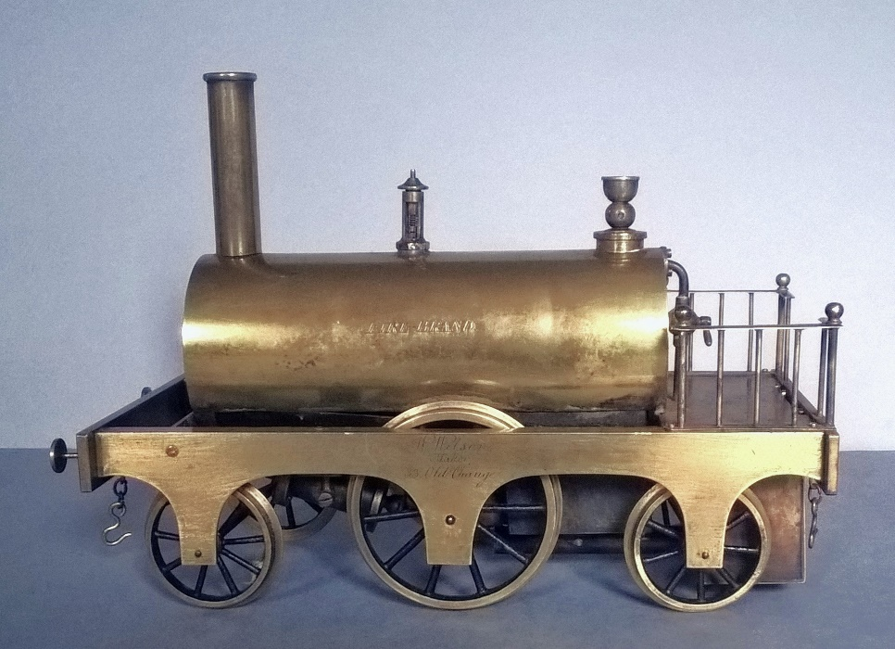
Fig 2a

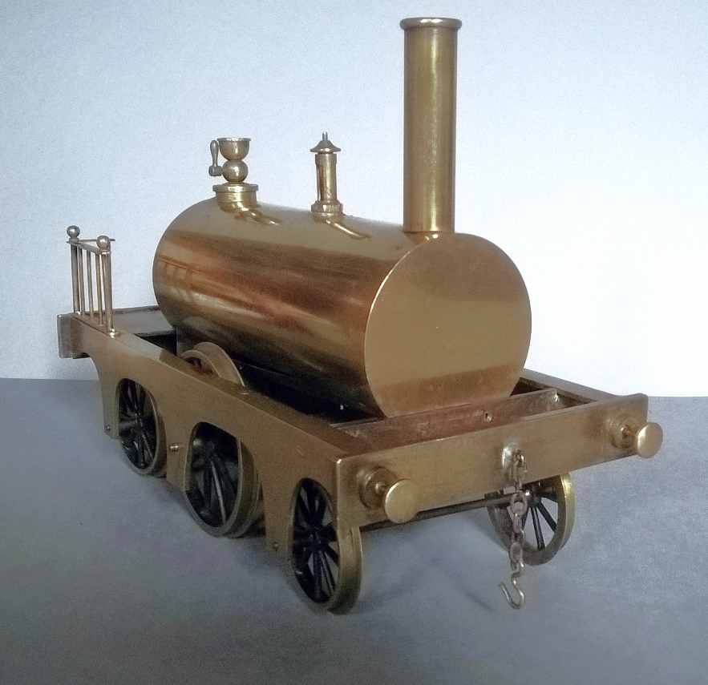
Fig 2b

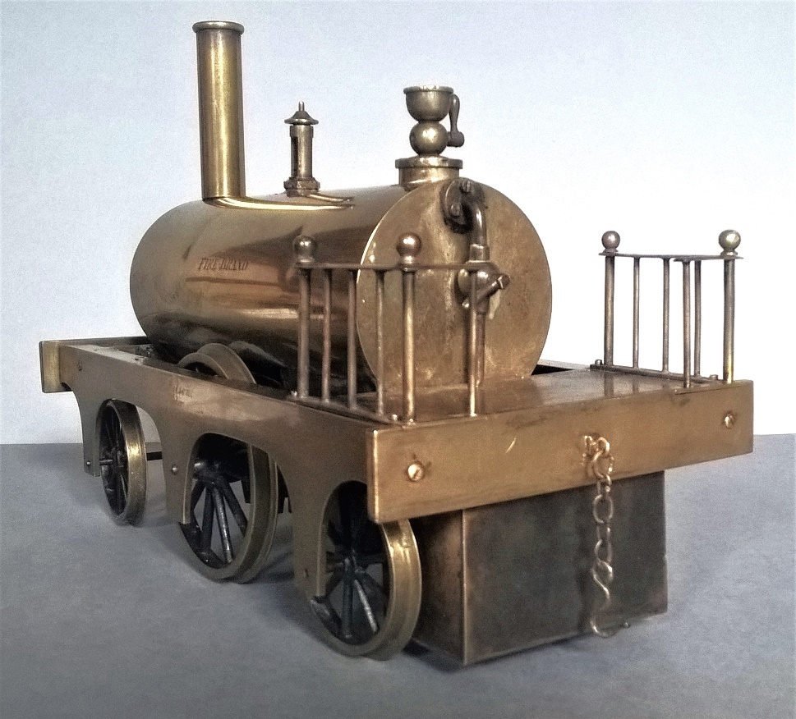
Fig 2c

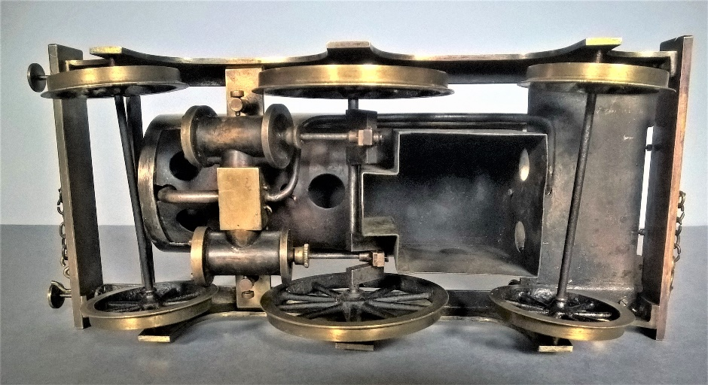
Fig 2d

We can start looking at other locos and we see all the signs of commonality. In the Philip Weiss Auction of ‘High End and Important Toys and Trains’ of 21 May 2021,
Lot 38 is anonymous and a very different sort of three-axle loco from Fire Brand, but the finish is similar, it uses the same wheels (albeit with the drivers flangeless), it shares the same cylinders, it has the same attention to detail in terms of burner shielding, it shares the same pattern of cup filler and dome, while the regulator is that of the Gogerty loco. It is probably a tad later than Fire Brand as it has a cross-cut, rather than plain footplate Figs 3a-d.

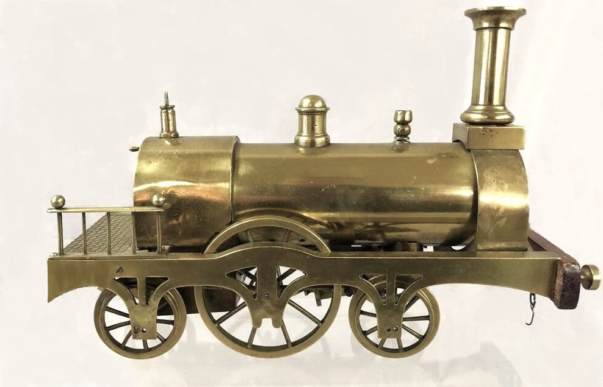
Fig 3a: The chimney looks too big for the smokebox and has likely been ‘borrowed’ from something else. It is probable that the original was like that in Fig 4. (Weiss auctioneers)

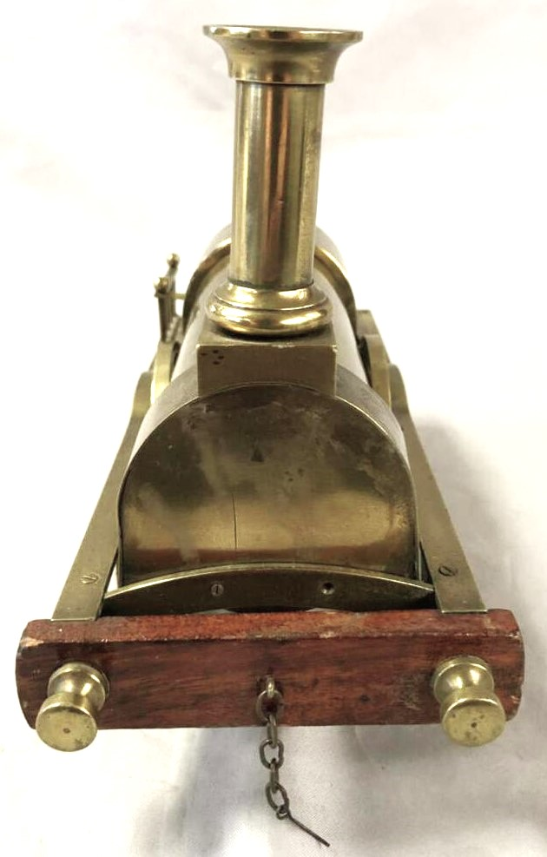
Fig 3b. (Weiss auctioneers)

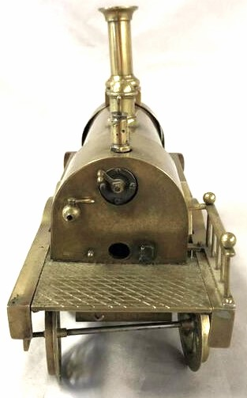
Fig 3c: The fire hole is, in fact, a lighting port for a match or taper. The cross-cutting is unusual with latitudinal cuts bisected by ones at 45⁰.(Weiss auctioneers)

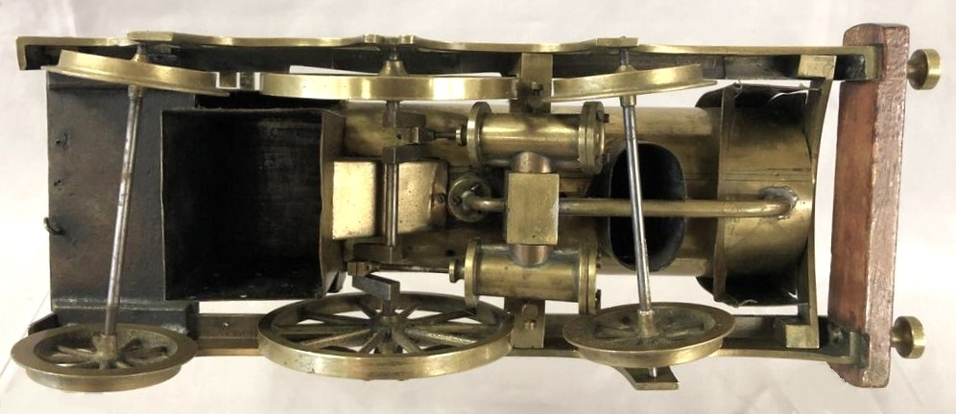
Fig 3d: In this case the burner looks to be flued under the boiler and out over the front axle, a very unusual arrangement. (Weiss auctioneers)

Turning to Fig 5 in Tim Armitage’s ‘Flangeless Locomotives’ at p33 in TC 55 is a loco marked for Henry West at 31 Cockspur Street. West was another instrument maker. He kept a number of premises, his Cockspur Street branch being run by his brother, Francis . The loco is a cross between Fire Brand and Lot 38, sharing the flangeless drivers and dome of the latter, while its tapered square chimney base is common to the two-axle locos I have seen Fig 4. It again has the same unusually cross-cut footplate Fig 4a.

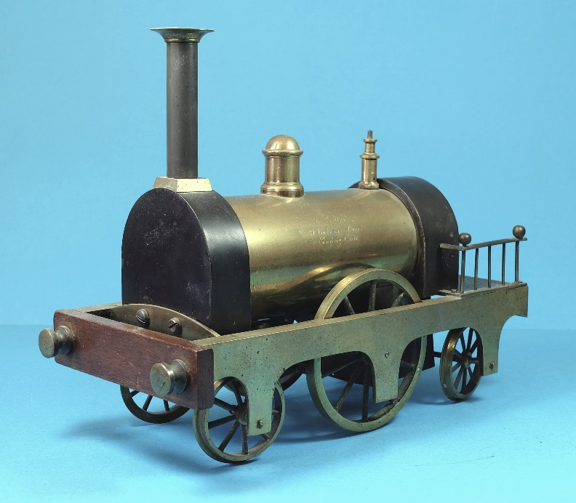
Fig 4. (Michael Bowes/Tim Armitage)
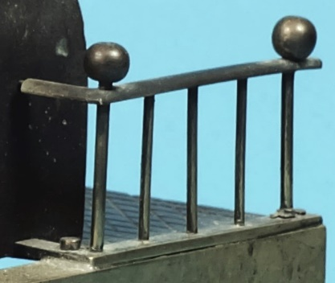
Fig 4a: Note the footplate with cuts at 90⁰ and 45⁰ identical to lot 38, while all the three-axle locos share slight variations on the same siderails.

Now, we can look at the three-axle loco inscribed for Watkins & Hill in Tim’s article in TC 62 p19. It is very similar to Fire Brand, but with wooden buffer beam, bowed cross member, flangeless drivers and cross-cut footplate akin to Lot 38. It has the tapered square chimney base and its dome and regulator is shared by the West and Weiss locos Fig 5.

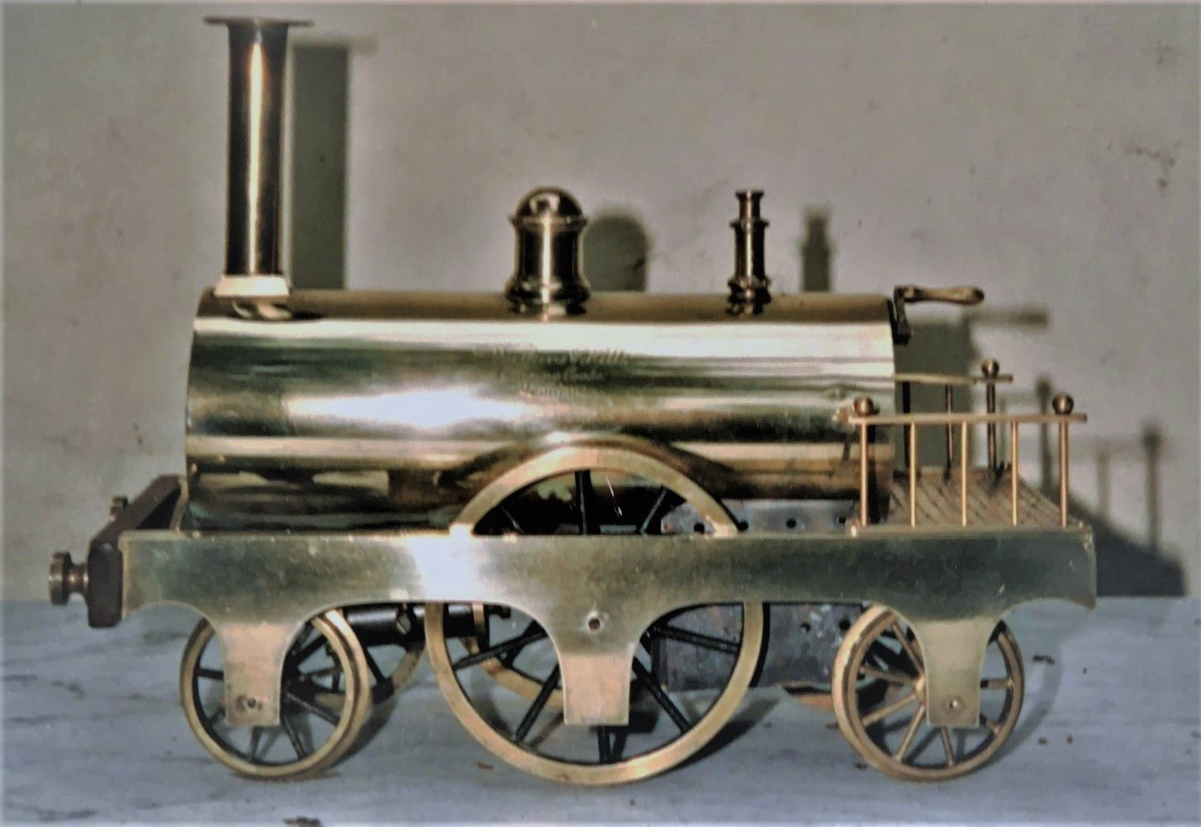
Fig 5: The bowed cross-member is just visible at the boiler front and the latitudinal cross-cuts clear. (Tim Armitage)

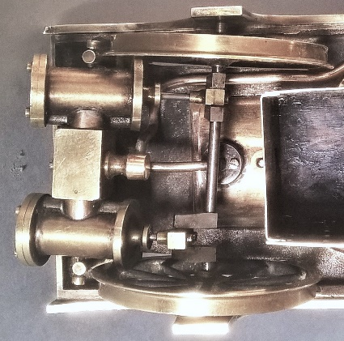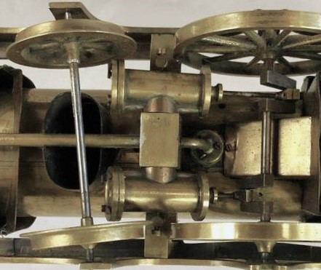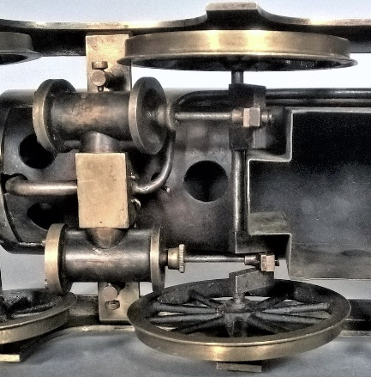
Fig 6: Cylinder blocks compared. Left, Gogerty (Figs 1); centre, Weiss (Figs 3); Right Fire Brand (Figs 2). They are identical save for Fire Brand having screw caps to the rod inlets and Gogerty having a separate inlet pipe socket.

Returning to the Weiss sale, Lot 37 is somewhat similar to the Gogerty loco, but I suspect somewhat later. It has a revised base with ‘normal’ cross-cut footplate, a simpler boiler with a heat channel and no burner shield. The dome is more substantial and has been moved forward, while the cylinders have a central rib and the regulator is no more than a tap. It has added detail in the form of buffers (similar to those of Lot 38 and figs 4 and 5), buffer beam and side rails. It is marked for Newton Fig 7a-d.

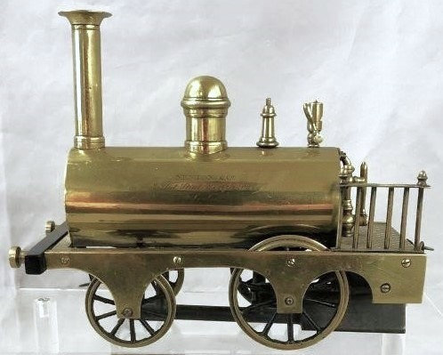
Fig 7a. (Weiss Auctioneers)
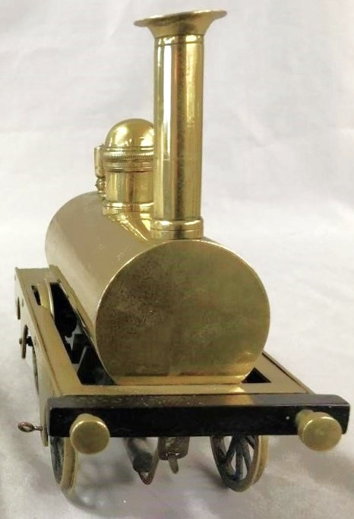
Fig 7b. (Weiss Auctioneers)

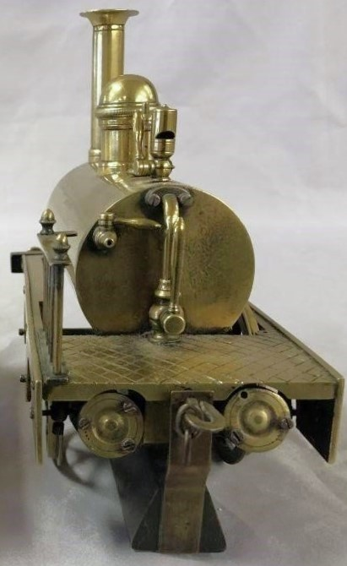
Fig 7c. (Weiss Auctioneers)

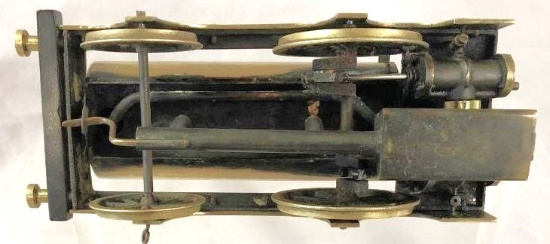
Fig 7d. (Weiss Auctioneers)

Finally, just to prove how small a world that of these early locos is and how easily we can think there are more of them surviving than there actually are, we can turn to Allen Levy’s A Century of Model Trains, where Fire Brand is illustrated on p12 and on p11 are the two locos from the Weiss sale. To me, the most telling commonality is that all the locos share a similar, idiosyncratic form of outside frame where the ends are arched and drop back down towards their termination. All other outside-frame toy locos that I have seen have straight-ends; so, the arched ends form an unusual signature feature that makes it pretty certain that all were built by the same maker. It is worth observing that the two-axle locos are quite standardised, but the three axle ones are all quite different. This suggests the two axle locos were stock output provided to the various retailers, while the three axle locos were likely made on a more individual basis, possibly to order, but equally likely just as ‘specials’ that were supplied to retailers on a one-off basis.

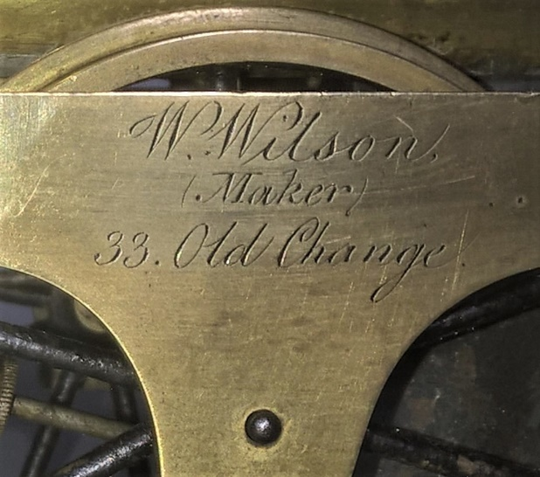
Fig 8.

What I had noted about Fire Brand was that its attribution to W Wilson, of 33 Old Change, was unusual in saying ‘maker’ (TC 60 p33) Fig 8. It is notable that none of the others make this claim. My interest expanded when there seemed to be no reference to Wilson on the web. Optical instrument makers are almost all listed on one site or another, Wilson was not amongst them (It should be noted that there was a scientific instrument maker in London called William Wilson, but he was not born until the mid-1850s and therefore merely confuses the issue) . Our W Wilson was at an appropriately east-central City address (Old Change was near St Paul’s); so, armed with both name and address, the first port of call is the Guildhall Library to look through street and trade directories. I was intrigued by what Wilson would describe his business as.

I find the best method with directories is to aim centrally, then work back and forward. For those unfamiliar with directories, most were published as ‘Kelly’s Post Office Directories’ on an annual basis and each provides a triangulation of a ‘commercial directory’ (an alphabetical list by surname), a ‘street directory’ that lists each street and the occupant of each property by house number, and a ‘trades directory’ that lists all those in the commercial directory under trade titles. A normal business will therefore have at least three different entries. Beginning with 1850, I hit gold. In that year 33 Old Change was occupied by a Wm Wilson who described himself himself as a ‘machinist & tobacconist’. From today’s perspective this seems a bizarre coupling of business interests, but it does strongly suggest that Wilson was indeed the source of all these brass locomotives. While all the other businesses describe themselves as opticians and/or instrument makers, these trades are not nearly as appropriate to the production of brass locomotives as Wilson’s, while none other than Wilson claim to be ‘maker’ of any of the locos I have seen. In fact, it is the pairing of businesses that makes Wilson such a likely candidate to be the source of the locos. As a tobacconist he would have had a continual passing trade in the City, a good proportion male and monied, to whom he could exhibit his models. My guess would be that at first Wilson put some of his models out for display in his shop and found that passers-by asked if they could buy one.

Wilson was not unique in seeming to operate seemingly oddly paired businesses, but ones in which there was an opportunity to gain customer reaction to models put on display in a shop. William Stevens went through a very similar transition . He set up as a newsagent in 1843, again in the City, at 23 Trinity Square, half a mile east of Old Change. In 1857 he became a ‘news agent & ship modeller &c’ and continued as such until 1865 when he moved to 22 Aldgate and the business we know him for, Stevens’ Model Dockyard, was consolidated. He added ‘steam engines & all the separate parts’ in 1868, but he probably had already begun dealing in them. It is notable that Newton’s name is to be found on early Stevens’ locos, just as it is on Wilson’s. A bit later Henry Joseph Wood did a rather similar transition.

Going back, we find Wilson’s first appearance at 33 Old Change is in 1827 when he was just a tobacconist. By 1840 he has become a grocer. Then, in 1845 we find him not only listed as a grocer in both commercial and street directories, but also as ‘machinist & engineer’ as a separate entry in the latter. In the trades directory he is listed under three trades, ‘grocers and tea dealers’, ‘Engineers’ (mechanical) and ‘Machinists’. This is clearly when Wilson seriously entered the machining trade and is likely to be when he started supplying toy locomotives. We have no idea of why and how he became a machinist, a hobby developed into a trade perhaps? He was clearly reluctant to drop the day-job, presumably the grocery provided an assured steady income and could be run by his family while he built up his new trade. In 1846 he combined the two, describing himself as ‘grocer and machinist’ in the street directory and ‘grocer & machinist & engineer’ in the commercial directory.

As mentioned above, in 1850 he returned to his first trade of tobacconist, but the fact that ‘machinist’ now comes first tells us that this aspect of the business had become the more significant, while he no longer used the term ‘engineer’. He continued to describe himself as a ‘machinist & tobacconist’ through a move to 30 Old Change until his last listing in 1864, not far off forty years from when he set up business in Old Change. We can get some idea of the household from census returns. In March 1861, aged 64, he had just moved to No30 ‘late 33’ with his wife Margaret, aged 61, and daughters Elizabeth (‘organist’) and Anne (‘domestic servant at home’). Looking at this, it seems likely that Wilson spent his time machining, while Margaret and Elizabeth (when she was not at the console) looked after the tobacconists and Anne looked after the house. 33 is unoccupied, but could still have been Wilson’s machine shop. For the census he describes himself as a ‘tobacconist’ only. We have no idea of the scale of Wilson’s machine shop, but even as a one-man-show, some fifteen or twenty years of building brass locomotives on a commercial basis would result in large numbers being made and considerable variation. One does wonder what happened to Wilson’s machine shop and trade when he left the business? It seems inconceivable that Stevens would not be aware of Wilson’s products, while Wilson’s exit is remarkably close to William Stevens first supplying steam locos and to the same customers as Wilson. I’ll return to this question later.

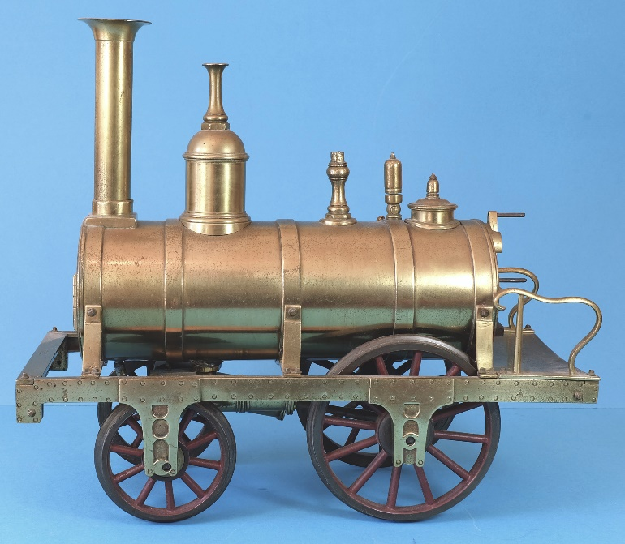
Fig 9. (Michael Bowes/Tim Armitage)

We do know that in this early period Wilson was not the only maker of commercial locos nationally. As Tim Armitage showed us in TC51 p32, rather more detailed four-wheel hot-iron fired locos were being offered in Sheffield Fig 9. The fact that Tim has found two examples that are more-or-less identical, one marked for Chesterman & Bottom (a company that functioned between 1843 and 1848), the other not, suggests that these locos were made by someone rather similar to Wilson who supplied them to retailers. From the point of view of industrial development, however, it seems it was the London trade, rather than Sheffield, that would expand in the 1860s and 1870s and subsequently act as the benchmark for the Birmingham makers of the 1880s and beyond, giving Wilson the honour of ‘setting the ball rolling’.

What this demonstrates is that manufacture of early brass locomotives was far less of a ‘profession’ than has generally been considered the case and that during the 1840s and ‘50s there were far fewer makers, in the case of the London trade, probably only one. This was not the trade of instrument makers using their time to build brass locos when they had far finer work to do. Rather, it was more entrepreneurial and likely to be driven by personal interest and opportunism. Newton, Watkins & Hill, Gogerty… why would these firms expend time and effort on such a product as a model loco when they could buy it in? Answer, they did not. Either William Wilson went to them, or they went to William Wilson.

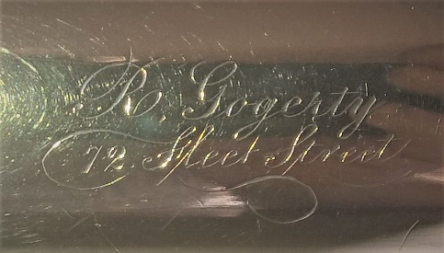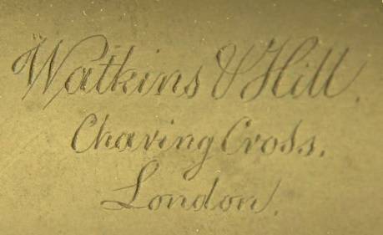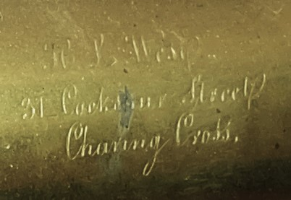
Fig 9: The inscriptions for Gogerty, Watkins& Hill and H J West seem to share the same hand as that on ‘Fire Brand’, presumably engraving names was a service offered by Wilson for all retailers who could not, or did not want to do this themselves.

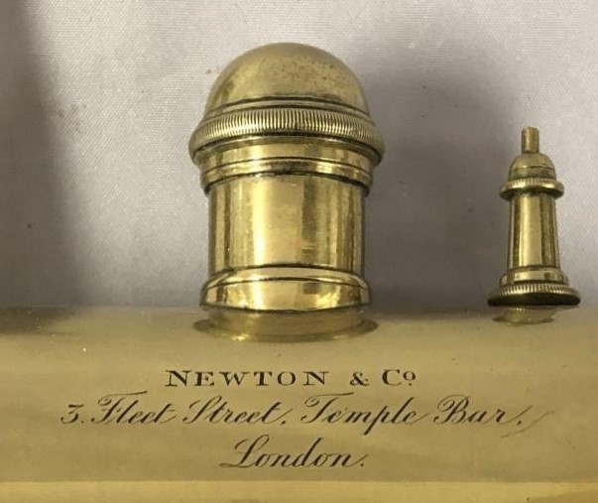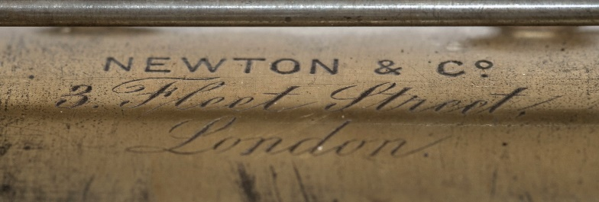
Fig 10: In comparison the Weiss loco’s engraving for Newton & Co (Left) is of a higher order and presumably done in house. This is, of course, on a later loco (Newton & Co was formed in 1857) and by this time the loco was made name engraving may not have been something offered by its maker. Prince (a considerably later Stevens’ loco, see below) has a similar quality of engraving that looks to be by the same hand.

THE LATER LONDON TRADE

At this point it is worth exploring the other major London makers of the 19th century by the story the entries in trade directories have to offer. What is very notable is that only one, other than Wilson, seems likely to have been active in brass locos prior to 1865, this being Edwin Bell. Bell’s business began when he took over from a Henry William A Farley, who set up a ‘Toy and Fancy Repository’ at 31 Fleet Street in 1840, having moved there from 25 Ludgate Street. For a few years in the mid-1840s his business also acted as a Post Office Receiving House (in the early days of the penny post). It was not until 1854 when he began to call himself a toy-dealer and naval modeller and only three years later, in 1857, his business passed on to Edwin Bell. Over the next seven years Bell turned it from a toy and fancy repository to ‘The Model Dockyard’, Bell consistently described himself as a ‘ship modeller’ in the trade directories. In this he was rather similar to William Stevens and like Stevens, the evidence points to him beginning to supply brass steam locos sometime in the 1860s, with the first documentary evidence The Model Dockyard Handy Book being published in the mid-1860s (second edition 1867) Fig 11. In this, Bell claims that his business is the only one of its kind in the country; so, we can assume that he was writing for the first edition in about 1865-66, before Stevens’ expanded business in Aldgate Street made its mark. The Model Dockyard Handy Book is only ‘edited’ by Bell, suggesting that a lot of the content was written by others. While its focus is on ship modelling, with steam engines coming second, it also covers a lot of other sports and pastimes.

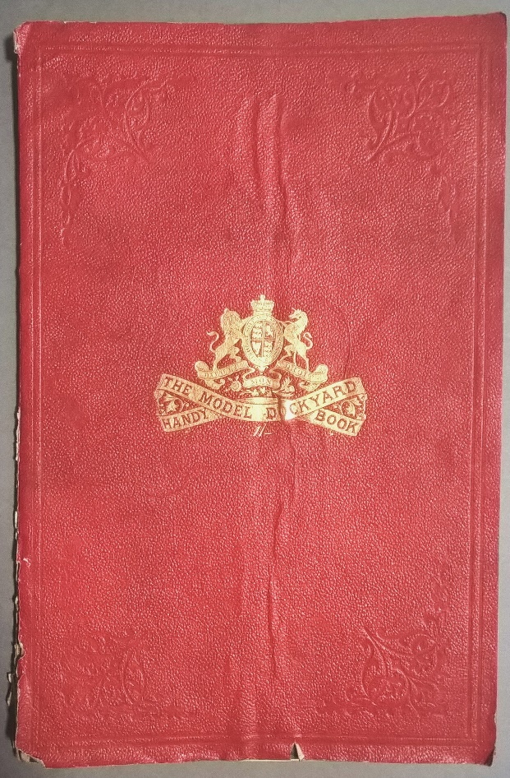
Fig 11: Cover of The Model Dockyard Handy Book (2nd Edn), rather grandiosely incorporating (probably illegally) the British royal arms into its title. Bell claimed to be ‘for several years Ship modeller and Mechanist to the Royal Family, The Emperor of the French, The Emperor of Austria, the King of Prussia’, along with five others, as well as ‘The Lords Commissioners of the English Admiralty, &c., &c., &c.,’

The first three editions of The Model Dockyard Handy Book only list two locomotives, with the emphasis on home assembly, suggesting they were a fairly new line. The great detail given to the various components suggests that, at the very least, Bell was commissioning them, if not making them himself. The three-axle loco illustrated, Earthquake, is considerably heavier and more ‘model-like’ than what we know of Wilson’s products, further suggesting that this was Bell’s own. To buy it made-up cost fifteen guineas, a good bit over £1500 today Fig 12.

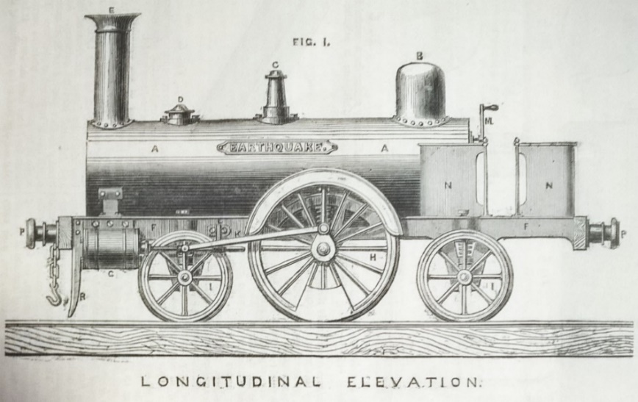
Fig 12.

A smaller, two axle version is listed, which could describe one of later versions Wilson’s locos, similar to the Weiss lot 37, with cranked axle, twin oscillators and ‘guard rails’. The lack of detail given to this loco, merely a parts list, further suggests it may well have been bought in Fig 13. Supplied made-up the loco cost five guineas, over £500 in today’s terms. These locos were luxury items indeed .

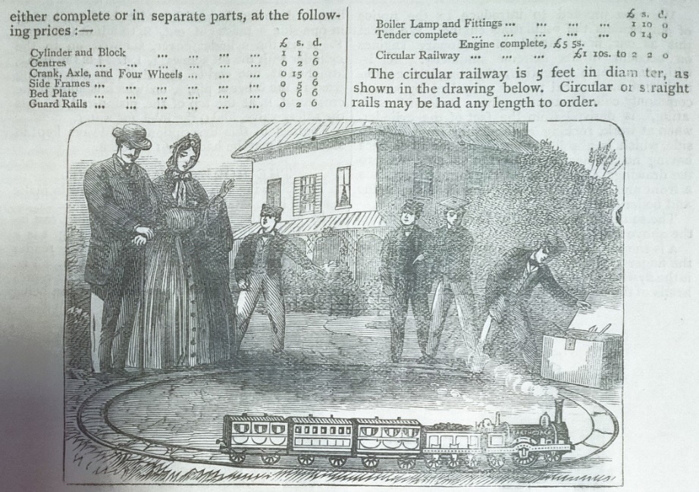
Fig 13: The picture seems fairly generic with the locomotive named Earthquake, even if of a very different specification.

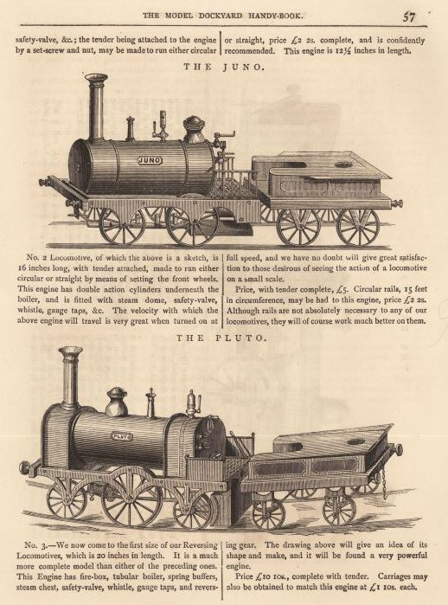
Fig 14: Page 57 from the 1872 edition. (Mike Cooke)

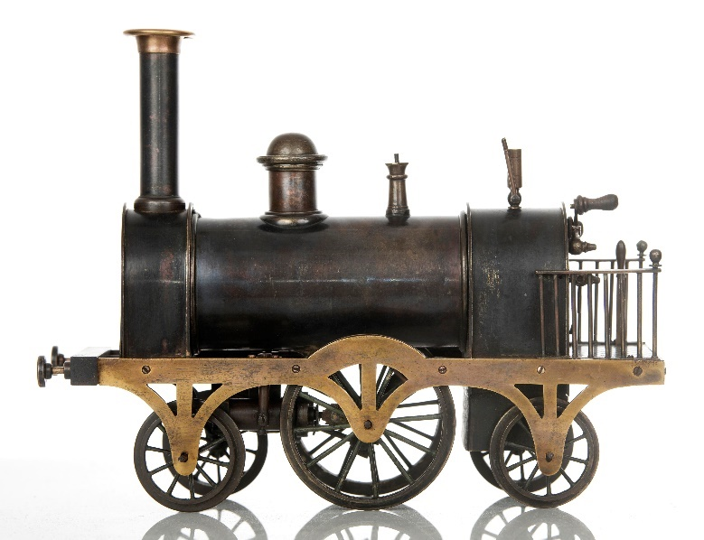
Fig 15: What seems to be an unnamed example of the Pluto in Fig 14 above.
By the time of the 1872 edition the range of locomotives had expanded to seven and all except ‘Earthquake’ are only offered made-up Figs 14&15. A question remains as to what was in-house and what bought-in? Whatever, it does seem that Bell was second only to Wilson in commercial brass loco manufacture in London. Other than producing what seems to be the first publication in which toy locomotives are detailed for the retail trade (no mean thing), Bell’s choice of business name, reflecting his interest in ship models, was probably his most significant contribution to toy train history, almost immediately being taken up by Stevens and, later, Clyde, amongst others.

I have mentioned William Stevens earlier, whose entry into steam model activities, like Bell’s, dates to the 1860s. Suffice to add that the longevity of Stevens’ ‘Model Dockyard’ (it lasted well into the inter-war period) has made Stevens the name of choice for dealers, auction houses and collectors to describe any brass locomotive they come across. There is little actual evidence of Stevens’ activities prior to 1900, but after this time they made only ‘best quality’ brass locos that they advertised as ‘our own make’. Others, bought in from elsewhere, they list either as ‘English make’, or, if imported, have no mention of maker whatsoever. I have yet to see or even hear of one of their catalogues that predates 1900; however, a few clearly Stevens and seemingly early locos survive. They are noticeably high-quality products, including Prince (a three-axle loco) Fig 16 and Pilot (a two-axle loco) Fig 17, both can be found engraved for Newton & Co. I suspect that Stevens took on where Wilson left off.

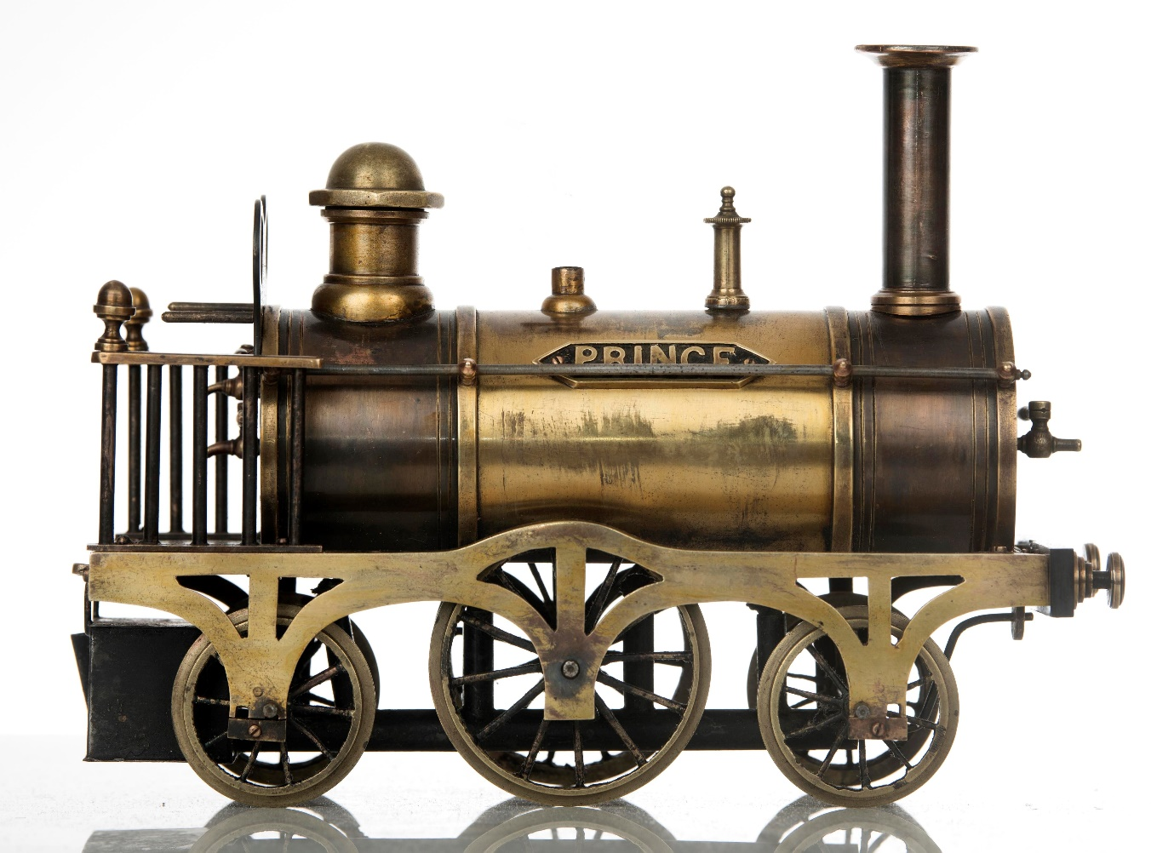
Fig 16: Prince is notable in having what would become the defining feature of best quality Stevens’ locos, heavily raised boiler bands. The pointed-end nameplate is also a feature of Stevens’ products. The loco’s whistle is missing.

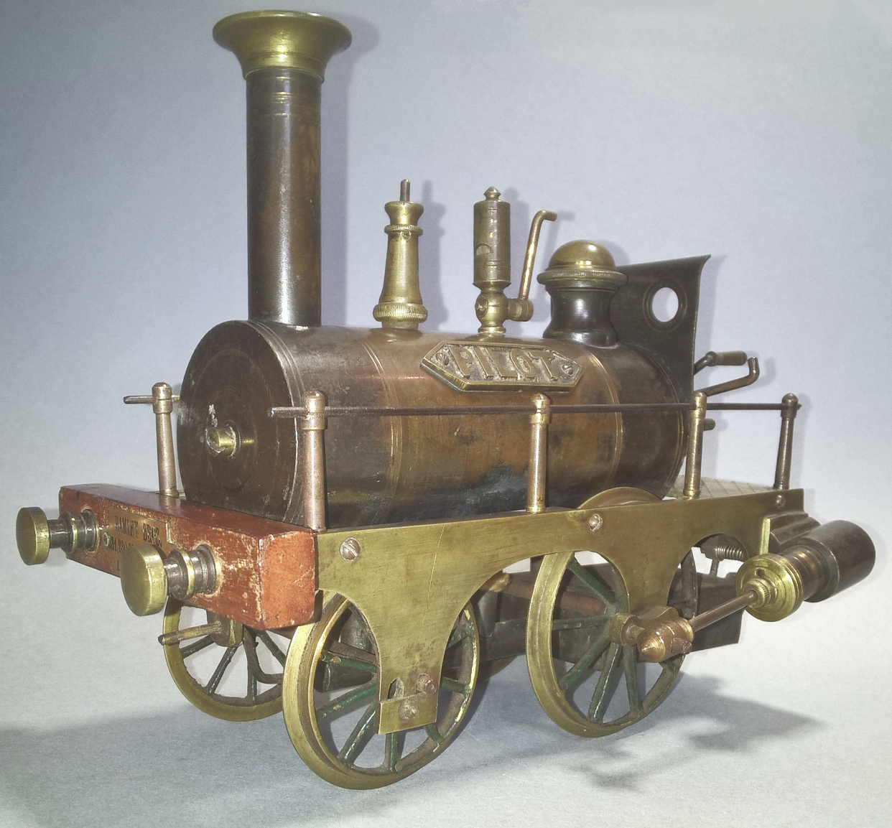
Fig 17.

The evidence for this can be seen in two locos. The first, the two-axle loco sold through Weiss we have looked at in Fig 7; the second, a very similar loco sold recently through Special Auction Services (SAS) Figs 18a-c. As we have seen, the Weiss loco has a lot of Wilson to it in its boiler fittings and curvaceous side plates. The SAS loco, though identical in overall structure, has straight ended side plates and boiler fittings identical to Pilot. In fact, it is more or less the same loco as Pilot, but with inside cylinders and short side rails (which are missing). It is as close as we are likely to get to supporting the idea that Stevens’ entry into making brass locomotives was not coincidental with Wilson’s departure, but instead was a straight-forward business transition.

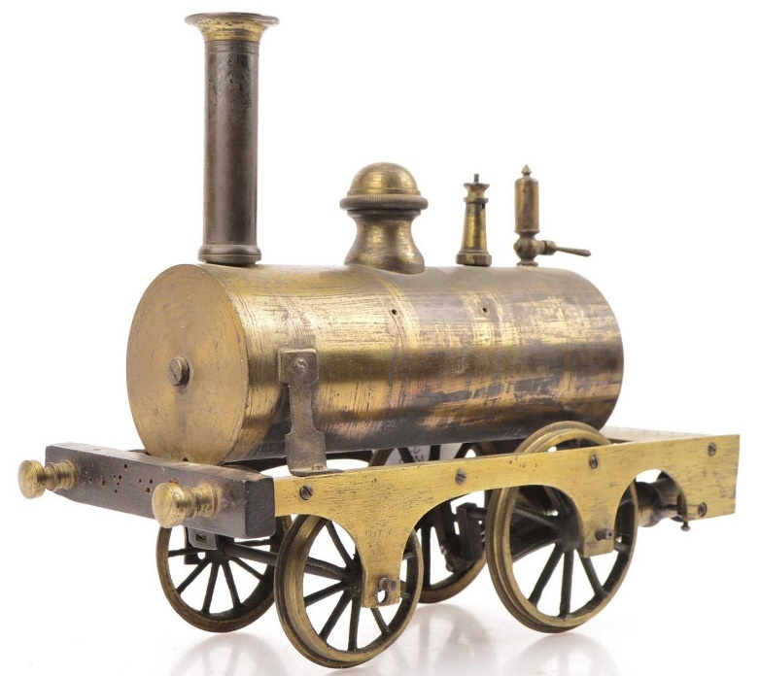
Fig 18a: Special Auction Services, 12 Dec 2023, Lot 852. Notice the screw holes for a name plate, typical of Stevens. Note also the similarity of fittings and frames to Pilot. The lack of weatherboard and the overall bright brass finish suggest this is an earlier loco than Pilot. (SAS)

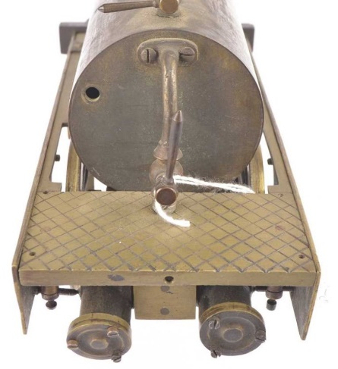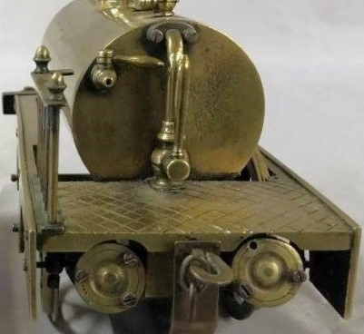
Fig 18b: As with the Weiss loco (right) the SAS loco’s footplate is cross cut in diamond pattern, while the fittings are identical. However, the cylinder block is now mounted to clear the rear beam.

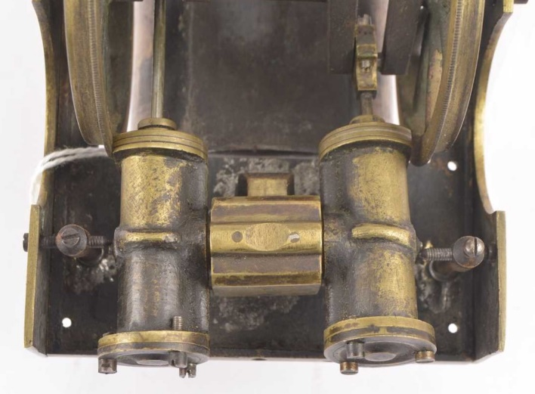
Fig 18c: The cylinder block of the SAS loco. (SAS)

A very significant name in the London trade was John Bateman, whose first appearance in the trade directories is in 1867 as the junior partner of Phillips & Bateman, opticians, of White Horse Road, Stepney. The following year he set up on his own as a ‘manufacturing optician’ operating from 131 High Holborn. Until 1876 nothing changes, but in 1877 he describes himself as an ‘experimental engineer’ with premises at 131 High Holborn and the Royal Polytechnic Institution 309 Regent Street, while also operating as an optician at 104 Strand. By 1885 he had expanded the optician business with additional premises at 117 Fleet Street and 29 Cheapside, but is no longer at the Royal Polytechnic. Then, in 1886, he takes over Edwin Bell’s ‘Model Dockyard’ at 53 Fleet Street and describes the business thus
.
Bateman John & Co., optician 104 Strand & 117 Fleet Street & 29 Cheapside; Experimental engineers and inventors, modellers & proprietors of The Model Dockyard (Est 1774) 131 High Holborn and 53 Fleet Street.

I suggest it is at this time that most Bateman locos date from. Moreover, we can be fairly certain that Bateman and his business had the capacity to make brass locos. The company expanded to its greatest extent in 1887 when there is a move from 131 to 205 & 206 High Holborn and ‘scientific opticians’ replaces ‘experimental engineers’; nevertheless, the optician businesses at Fleet Street and Cheapside disappear, presumably to make way for Bell’s Model Dockyard. A year later ‘scientific opticians’ is replaced by ‘mechanical engineers’ and in 1889 the Strand premises move from 104 to 101. Finally, by 1895, John Bateman & Co had shed all but the High Holborn premises, where they remain as ‘mechanical engineers’ until well into the 20th century. It is interesting that, in spite of such a long history and issuing an extensive catalogue in about 1889 (datable by the premises mentioned and which has been reprinted), Bateman & Co have been largely forgotten. It is worthwhile to note that Reder wrongly dated this catalogue to 1879 (p12), inadvertently pushing toy train history back by a decade. Reder did this also with The British Modelling and Electrical Co catalogue of c1900 , which he dated (presumably on the style of the locos illustrated) to ‘1888-90’ (p18). In spite of this, Bateman’s catalogue is still immensely significant as, even in 1889, it is one of the earliest yet known to display a wide range of Birmingham style locos alongside those seemingly made in-house. What is certain is that Bateman locos are very unlikely to date much before 1880 and quite likely they continued in production until well into the 20th century.

I was intrigued to follow one of Tim’s ‘forgotten firms’, William Faulkner (TC 59 p30). Faulkner first appears in the early 1860s as a ‘surgeon & registrar’ (of births and deaths) based at 40 Endell Street. We can only assume that, like others, he developed a hobby into a business, in his case in the late 1870s. In 1880 he remains a surgeon and registrar at Endell Street, but is also the Faulkner of Faulkner Bedford & Co, Engineers, of 468 New Oxford Street. Five years later, in 1885, both businesses are at 16 Endell Street. In 1890 the surgeon and registrar business has moved to 22A Endell Street, while Faulkner Bedford & Co are now ‘electricians and engineers’. In 1895 both businesses are back together in 16 Endell Street and in 1900 only ‘Surgeon & Registrar of births and deaths’ is listed. Tim’s loco, with the New Oxford Street address, has to be early 1880s.

Finally, Henry Joseph Wood, who, in historical terms, is somewhat overshadowed by his musical son, Sir Henry Wood, who set up the Proms. Wood’s locos are very desirable to brass loco collectors, many of the survivors have reference to Stirling singles and, like Wilson’s, all Wood’s locos are very well built, but more substantial and are usually painted and lined. Wood’s first trade seems to have been pawnbroking and from this he became a jeweller and optician, one might guess from having to value a lot of such items brought in for pawn. He has no presence in the trade directories until 1868 when he is at 413A Oxford Street as a ‘jeweller and optician’. He is still living there at the time of the 1871 census, aged 42, with his wife Martha, also 42, and son, Henry, aged 2. He drops out of the directories in 1872-3, presumably while he moved his business to 429 Oxford Street. Although his 1874 entry merely states ‘optician’ he seems to have begun to develop the business as a commercial modelmaker because in 1875 it has moved again, to 355 Oxford Street, where he describes it as

Manufacturing optician and engineering modeler & large stock of every description of working models, telescopes, opera glasses, mathematical instruments, spectacles, eyeglasses, etc.

This suggests that Wood, like Stevens, bought in a lot of what he sold, reserving his and his staff’s skills for best work and it is only this that is now recognisable to collectors. Even though many are unmarked or marked for others, like Wilson’s, the very idiosyncratic nature of Wood’s products makes them easily spotted by those who have studied them. Although the description is nebulous, it might suggest that in 1875 it was possible for Wood to buy-in ‘working models’ from makers in Birmingham, the first hint of any toy locomotive making activity there, although there is as yet no true evidence of this being the case. Ten years later Wood moved to 185 Oxford Street. In the 1891 census he and Martha are both 62 and he describes himself as a ‘Model Engineer and Optician’, while Henry, now a 22-year-old ‘Music Composer’, is still living with them. However, in 1892 the directory description is reduced to ‘optician’ only, perhaps suggesting Wood was running the business down. It was last listed in 1895 when Wood would have been 66.

What we see in these ‘second generation’ firms is the same pattern that we see in William Wilson, almost all seem to have started with one, often unrelated trade or profession and then developed a business in model making as a side line, some, like Faulkner, never actually ‘giving up the day job’. It is also interesting to note how pioneering William Wilson was in the London trade, seemingly having it largely to himself for a decade or more. It was only in the1860s, more-or-less when Wilson ceased trading, that new makers began to emerge and the market was developed enough to support them. Moreover, it is not really until the 1880s that we can clearly see the structure of a small, elite ‘London Make’ alongside a far larger Birmingham industry operating through wholesale and sometimes retail illustrated catalogues, which many collectors incorrectly believe has a far longer history.

There is a bit of a moral to this story. Fire Brand, with its inscription ‘W Wilson – Maker – 33 Old Change’ and the two other locos in A Century of Model Trains have been known to collectors for decades, and in 1970 all three were owned by Jonathan Minns. The trade directories for London have been available in the Guildhall since they were published. The research here is not rocket science, yet Minns published an entire book without doing any of it. Unfortunately, the guesswork he presented there was repeated in A Century of Model Trains and ad-infinitum thereafter so as to have taken on mythic status today. Revisionist history comes hard and there may be a good bit of incredulity when some people read this, but almost all the research here could have been done fifty years ago. It says something of train collectors that it has taken so long to get to this point, even.

APPENDIX, Key names and dates

1845-6: William Wilson sets up as a ‘machinist’ and soon begins to sell brass locomotives to significant instrument makers such as Watkins & Hill, Gogerty and (later) Newton & Co, who sell them under their own names. Wilson’s locos are characterised by their simple outline, fine build quality and spirit firing. They set the pattern on which all British commercial brass locomotives would be based.

1857-c1865: Edwin Bell develops his business into ‘The Model Dockyard’, publishing The Model Dockyard Handy Book in about 1866, at the time of writing this is the first ‘catalogue’ known to list brass locomotives and their components for sale.

1864-65: William Wilson ceases trading, he would have been 67 or 68 at this time. It is likely that his business was taken up by William Stevens.

1865: William Stevens sets up his expanded ship model business in Aldgate and by 1868 is selling brass steam engines and components having (probably) acquired Wilson’s trade. He soon adopts Bell’s ‘Model Dockyard’ moniker. He continues selling to other retailers including Newton & Co (Watkins & Hill and Gogerty having ceased trading in the mid-1850s).

1867+: Edwin Bell and William Stevens dominate the London trade though their ‘Model Dockyards’. Both sell a wide range of models, increasingly by makers other than themselves. The larger, own-make Stevens’ locos take on a lot of the ‘weight’ of Bell’s, while the smaller remain lighter, like Wilson’s, although they are normally outside cylindered.

1870s: other named London makers begin to appear, such as H J Wood and William Faulkner. They tend to operate at the upper end of the market. In general, brass locos adopt outside, rather than inside cylinders, which are far easier to fit.

1870s-80s: an industry in Birmingham develops, centred in the Jewellery Quarter, largely copying the style of loco first introduced by Wilson in the 1840s and developed by Bell and Stevens in the 1860s-70s, but often at lower build quality. They are sold nationally and internationally (particularly to France) through a network of wholesalers. It is difficult to compete with the Birmingham trade for the general market, explaining the high level of products of London and indeed any other makers.

1886: John Bateman takes over The Model Dockyard. With neither Wilson nor Bell still active, this could be seen to mark the end of the ‘pioneering’ period of commercial UK model loco production.

AKNOWLEDGEMENTS
Thanks are due to a number of people in showing me examples of locos and literature, allowing the use of images and/or just talking about things. They are (in alphabetical order): Tim Armitage, John Bentley, Mike Cooke, David Pressland, Alex Procyk, Special Action Services, Clem Thomas, Weiss Auctions, Anthony Warren.

Neither Louis Hertz in Riding the Tinplate Rails (1944) and Collecting Model Trains (1956), nor Reder in 1969 make any suggestion that English brass locos were made by instrument makers, but Minns does and this was repeated in Levy, a book that Minns contributed to.
http://www.earlyphotography.co.uk/site/companies1.html#G
Watkins & Hill last traded under that name in 1856 when they were taken over by Elliot Brothers.
Newton & Co was formed by Frederick Newton after the partnership of WE & F Newton (established 1851) broke up in late 1856 or early 57. See: http://www.microscopist.net/NewtonCo.html
The Microscopist suggests that Newton & Co made optics, with most of the brass bodies for their equipment being bought in from external contractors. See: http://www.microscopist.net/NewtonCo.html
http://www.microscopist.net/WestH.html
A timeline for this later William Wilson can be found at https://physicsmuseum.uq.edu.au/system/storage/serve/30307/Timeline%20for%20W.docx Interestingly, in 1900 he also ran a tobacconist shop in Chalk Farm Road, while his workshop was in Belmont street nearby.
See TC 54, p31.
The Model Dockyard Handybook (Third edition, 1868) is available to download on Google Books.
It is notable from the parts list that the loco clearly had twin inside oscillating cylinders, yet remains unexplained. Then, in the next paragraph, a great deal of detail is given to the single oscillating cylinder on a vertical engine, further suggesting the loco was no more than an adjunct to Bell’s range.
In working out comparative prices one should take standard of living into account. A good weekly wage in the UK of the 1850s was £2 10s, less than half of 5gns (£5 5s). It is currently about £600, well over the comparative price of the loco. Even on statutory minimum wage in 2024 a 40-hour week is £457.60, nearly the comparative price of the loco, there was no minimum in the 19th century.
TC 54 pp30-31
TC 54 p32
So far the earliest datable catalogue that seems to list a large range of Birmingham locos (in spite of claiming not to) is by A Francois. By the various testimonials cited it dates to about 1885. See TC 54 p32. The very wide range offered suggests the trade was already well established.

