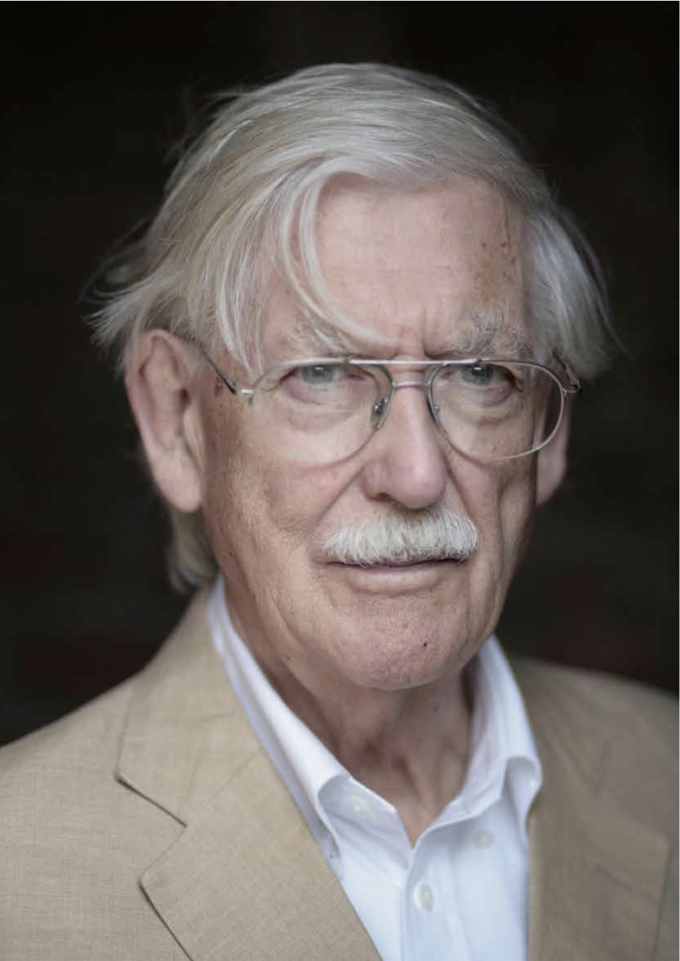
RIAS QUARTERLY AUTUMN 2014
ANDY MACMILLAN
11.12.1928-16.8.2014
ANDY MACMILLAN’S SUDDEN DEATH LED TO OBITUARIES AND TRIBUTES IN THE POPULAR AND PROFESSIONAL PRESS, RECOGNISING HIS UNIQUE CONTRIBUTION TO SCOTLAND OVER THE LAST SIXTY PLUS YEARS. THIS APPRECIATION AND THE WORDS OF 16 OF THE INCORPORATION’S PAST PRESIDENTS REFLECT THE UNIQUE CHARACTER, HUMOUR AND FUNDAMENTAL DECENCY OF THN. HE WILL BE MUCH MISSED.
40
AUTUMN 2014 RIAS QUARTERLY

A LIFE WELL LIVED
RELAXING WITH STAFF - GILLESPIE, KIDD & COIA ARCHIVE
Andy MacMillan was post war Scotland’s most charismatic champion of the art of architecture. His tireless and infectious advocacy reached wide audiences and his activities stretched from internationally-significant architectural practice to academic leadership, teaching, writing, broadcasting and chairing architectural competition and award juries. He was an outstanding designer, draughtsman and an unforgettable teacher. In person he was indefatigable, incorrigible, passionate, iconoclastic, witty, fun, down to earth and seemingly indestructible. He left this world peacefully after suffering a brain haemorrhage at the end of another good day’s architectural work judging the RIAS 2014 Doolan Prize. He was 85 and had been immersed in architectural activities for almost seventy years.
He will be chiefly remembered for two key architectural legacies; in practice and in education.
His partnership with Isi Metzstein and their creative leadership of Gillespie, Kidd and Coia produced a body of religious and educational work that revelled in spatial virtuosity, tectonic quality and the poetic expression of structure and light and brought the practice the RIBA Gold Medal in 1969. That output extended the architectural language of the first generation of modern architects by drawing on both historical as well as contemporary sources for its inspiration. Their architectural preoccupations and values were explored vividly in the 1999 exhibition, Themes and Variations curated by Mark Baines and the subsequent book, Gillespie, Kidd and Coia, 1954-87 by Johnny Rodger, published by the RIAS.
Andy was Emeritus Professor of Architecture at the University of Glasgow and a pioneering Head of the Mackintosh School of Architecture at the Glasgow School of Art. He taught and lectured across the world and held visiting professorships at several international universities. With his much-missed partner Isi Metzstein he was awarded the RIBA Annie Spink Award for excellence in teaching and he had a profound influence on several generations of architectural students. The interlacing of academia and the profession throughout his life placed him within a European tradition of a practising professor rather than the UK higher education orthodoxy of becoming a traditional university- based academic.
My first encounter with Andy was almost 40 years ago to the day when, as a seventeen year old part time student at the Mac, I attended one of his history of architecture lectures. Two things about that talk were memorable, typifying his personality. One was the collection of his evocative coloured acetate sketches he used throughout and the second was his reference to an article in Playboy magazine that he had read; a publication which, to my knowledge, has yet to be included in any recommended peer reviewed journal
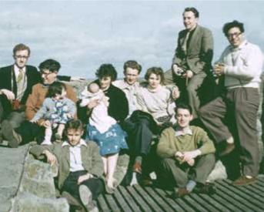
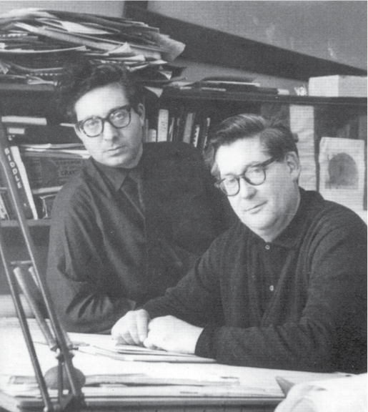
41
COURTESY OF ARCHIVES AND COLLECTIONS, THE GLASGOW SCHOOL OF ART
COURTESY OF ARCHIVES AND COLLECTIONS, THE GLASGOW SCHOOL OF ART
MACMILLAN

AT OUR LADY OF GOOD COUNSEL © EPIC SCOTLAND
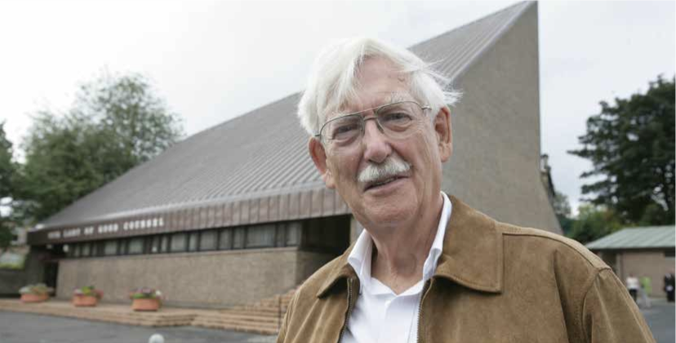

listings. Andy’s love of drawing and his unpredictable sources of references characterised his lively and passionate approach to architecture. He had a gift of communication, could command an audience and was a master raconteur.
As I got to know him as a student in the years that followed, his availability to discuss student studio projects seemed endless. I was able to knock on his door for a personal tutorial whenever he was around or see him in the studio. We students seemed to have access to him despite his many other duties as Head and partner in practice. How he managed this, was and (now that I also combine being a Head and practice), still is a mystery to me. The tutorial routine seldom changed; my drawings were greeted by him with some brief colourful comments followed by his swift but insightful sketches, reframing my attempts in a more compelling way. I learned from him by watching and doing rather than intellectualising at arm’s length. His own formative years were spent in an office, rather than a university and this gave his approach to studio education a direct and uncompromising
flavour. Without irony, we would be instructed with, “don’t listen to what an architect says, look instead at what they do.” We had, however, the opportunity to make similar assessments of Andy’s own architecture given that he had a very visible and visitable body of work in the public domain and he welcomed those discussions with us.
Andy remained busy after his official retirement as Head. He was awarded Lifetime Awards from the RIAS and Scottish Design. He was chair of the RIAS Doolan Best Building in Scotland Award, became Honorary Vice President of the Glasgow School of Art, Charles Rennie Mackintosh and Alexander Thomson societies. He took great interest in the work of emerging practices, particularly those led by Mac alumni and his attendance at our own practice openings always gave us special pride. After I became Head of the Mackintosh School, he became an enthusiastic collaborator on our book, Uneasy Balance, exploring the relationship between Mackintosh’s School of Art and Steven Holl’s Reid Building or as he put it, ‘my latest deep thoughts on Mackintosh’. Our planned
MACMILLAN / METZSTEIN AT ST PATRICK’S, KILSYTH, 2007 © KIERAN DODDS; SWITZERLAND DELEGATION 2010 © NEIL BAXTER
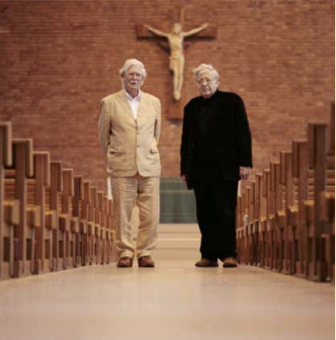
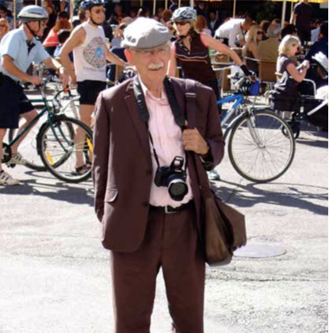

series of publications over the next few years exploring other aspects of Mackintosh’s Glasgow School of Art Building will sadly have to proceed without his involvement.
In today’s audit-focussed learning and teaching industry, it’s hard to accommodate Andy’s approach to academic administration obligations (“don’t do it” was his advice!). However, his cavalier attitude to the processes and procedures of institutions contrasted sharply with his availability, seriousness and generosity as a tutor. The passion and extent of his creative output help remind us all of what is in the long run vital and what is not.
In some ways, Andy never left the Mac and the Mac never left him. His scholarly interest in Mackintosh’s School of Art building and his paternal interest in the Mackintosh School of Architecture remained throughout his life. He enjoyed popping in for coffee and a chat with former colleagues and his name will always be associated with the institution he loved so much. His last visit to us was shortly after the recent fire and he was anxious to study the damaged library. Characteristic of his personal as well
as intellectual, relationship with Mackintosh’s masterpiece, he told me afterwards that the recently damaged and newly exposed structure had both brought a tear to his eye and also made him realise that he hadn’t fully understood Mackintosh’s construction after all these years. We will sadly never hear his revised version of that lecture.
Andy was the consummate architect, teacher and remained a student of architecture through and through. He leaves behind both a large community of colleagues, alumni and architectural friends across the world as well as a huge hole in UK architectural life. He was the very embodiment of a life led to the full and one immersed in creativity and learning. It is no exaggeration to admit that we loved him deeply.
PROFESSOR CHRISTOPHER PLATT FRIAS
HEAD OF THE MACKINTOSH SCHOOL OF ARCHITECTURE
43

